How can you create a website/blog?
1. Go to www.weebly.com
2. Enter your username, password and email in the appropriate location.

Important Note: Weebly provides a FREE SERVICE. You shouldn’t need to pay anything. You do not need to register a special domain name or pay for any of the special services offered in the “pro” plan.

3. Name your site (use a professional name! this will be published!)
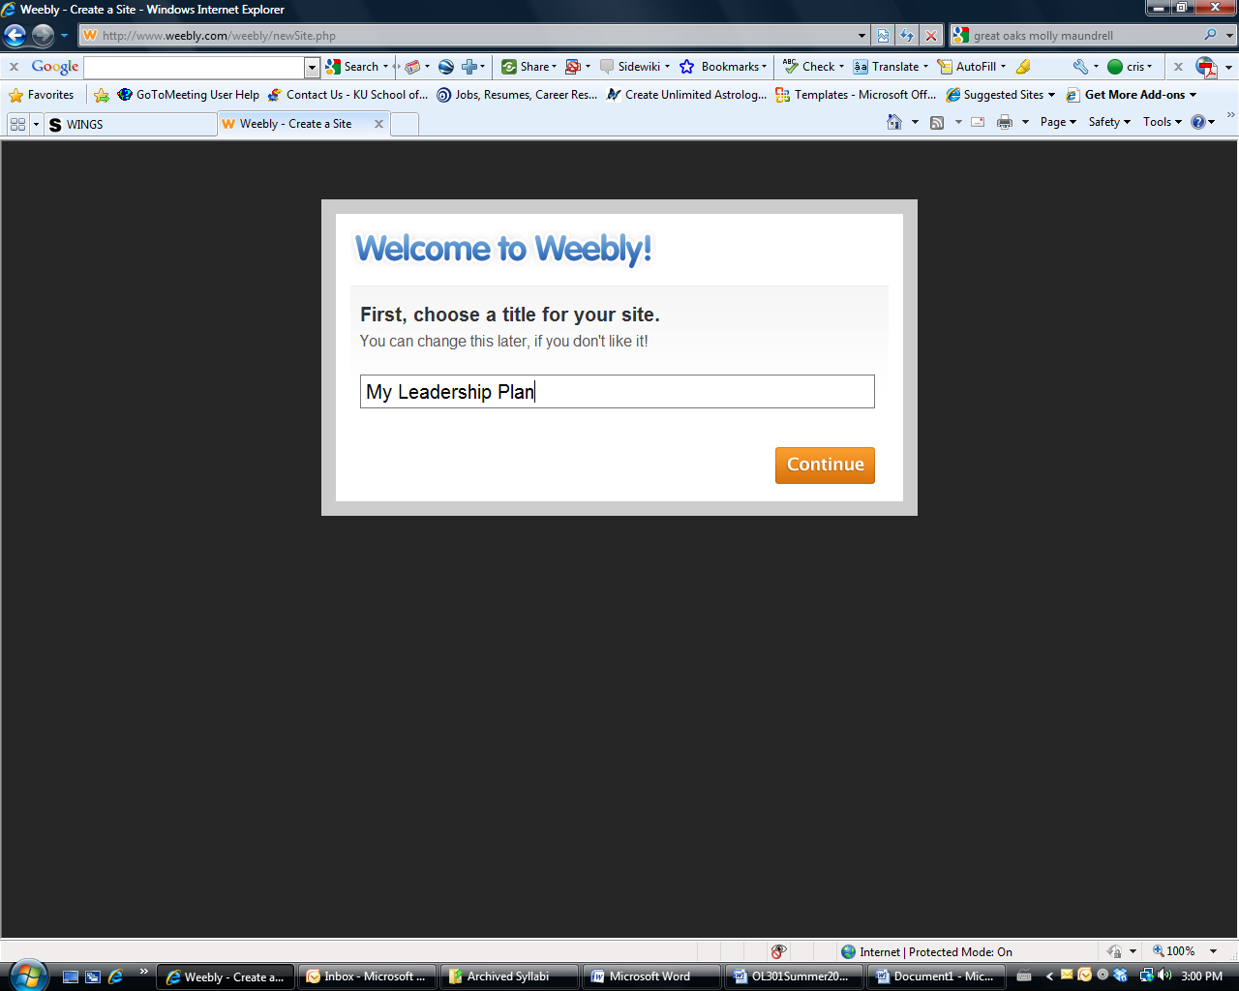

4. Choose a Website Address
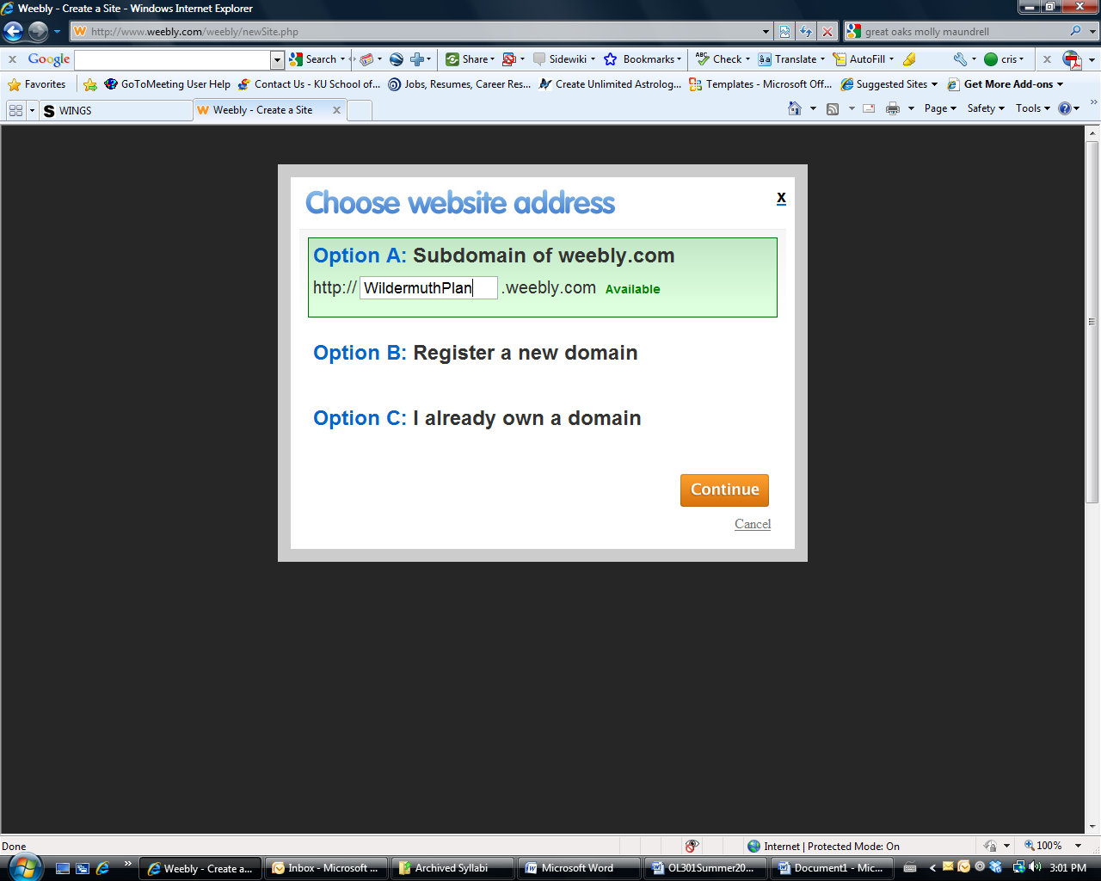
5. Click on the DESIGN Tab
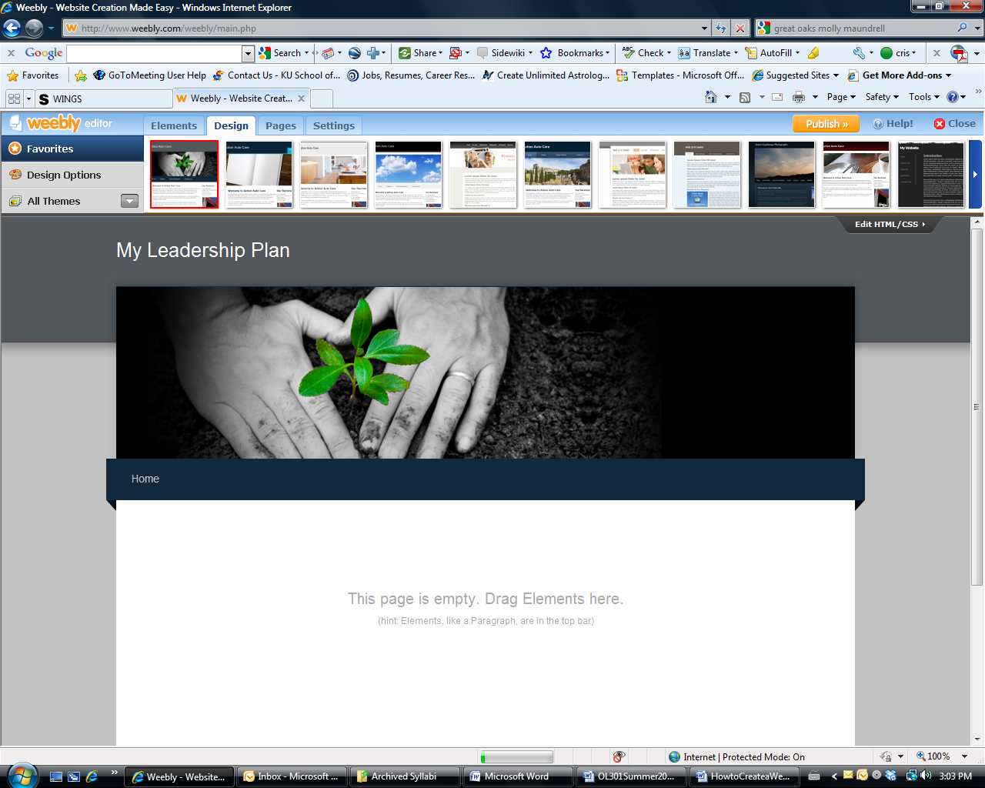
6. Pick a theme you like
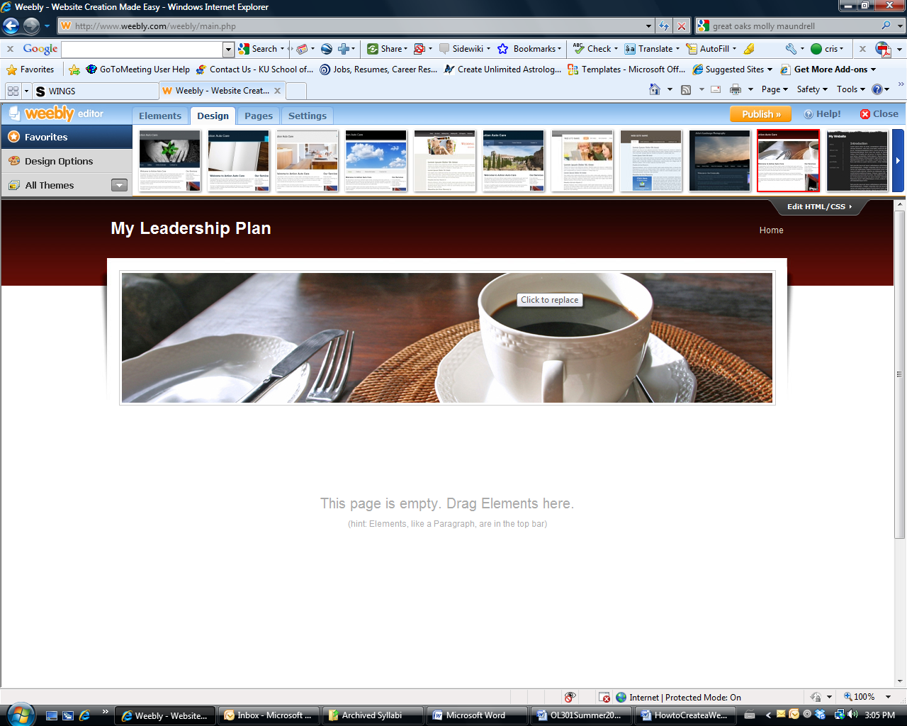

7. Click on the ELEMENTS Tab
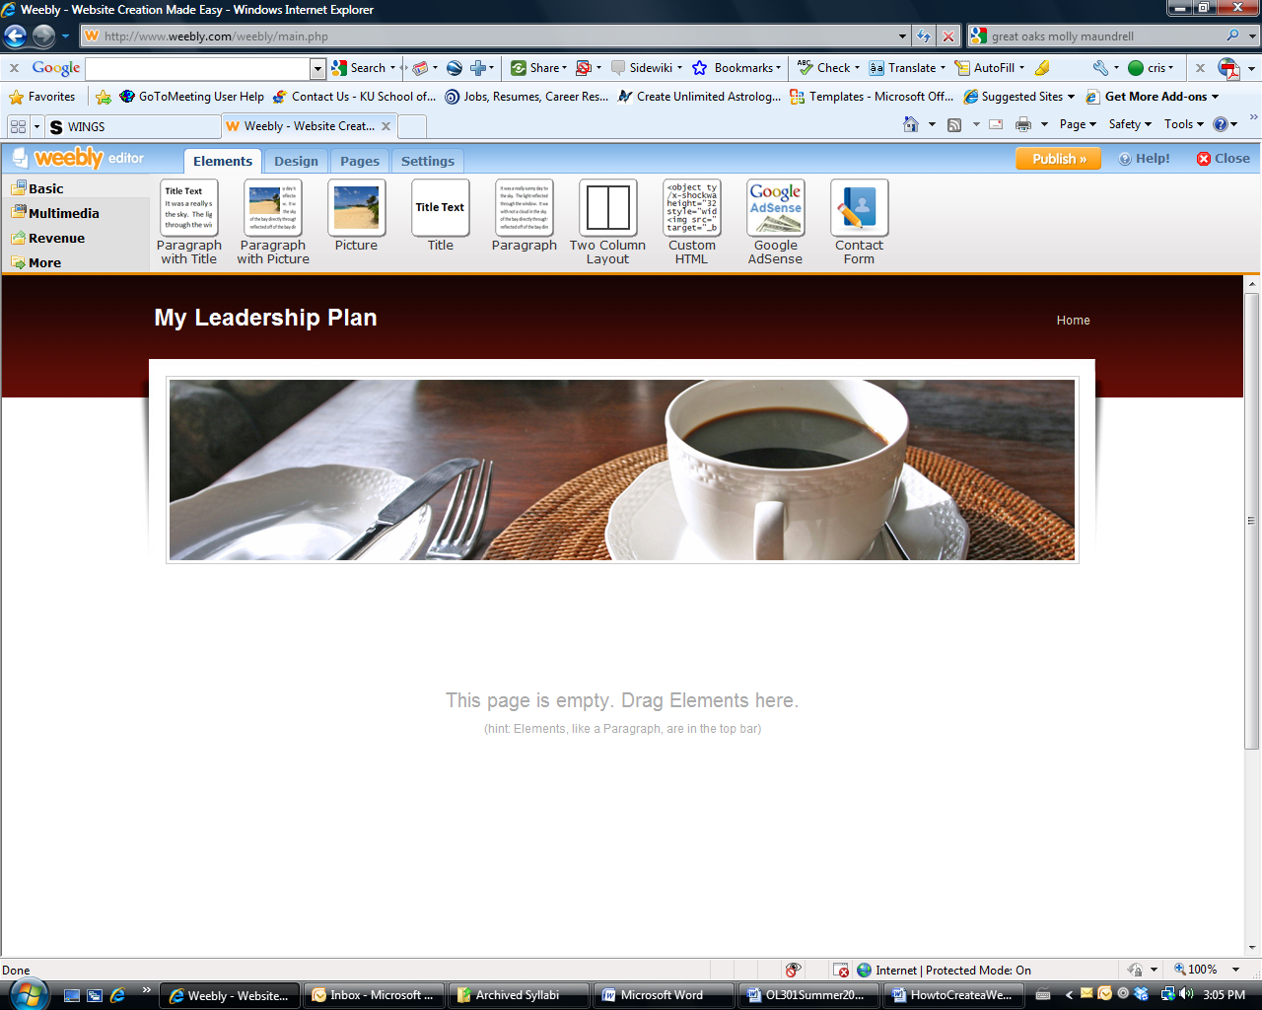

8. Drag elements down to enter text on your page.
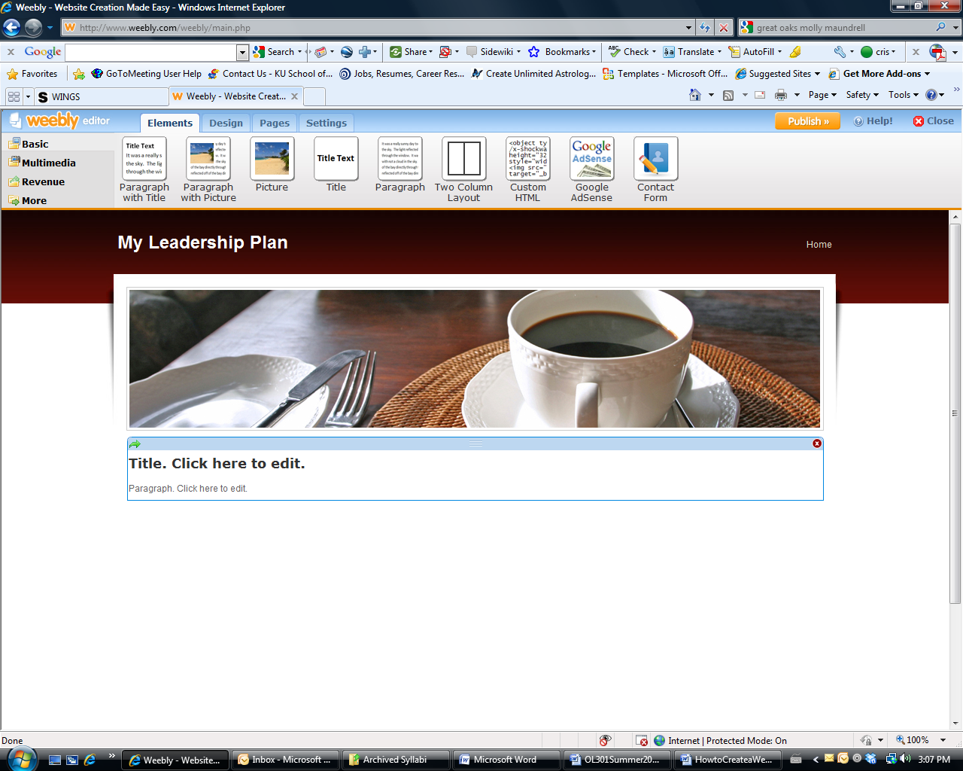

9. Enter text in the Introductory Page
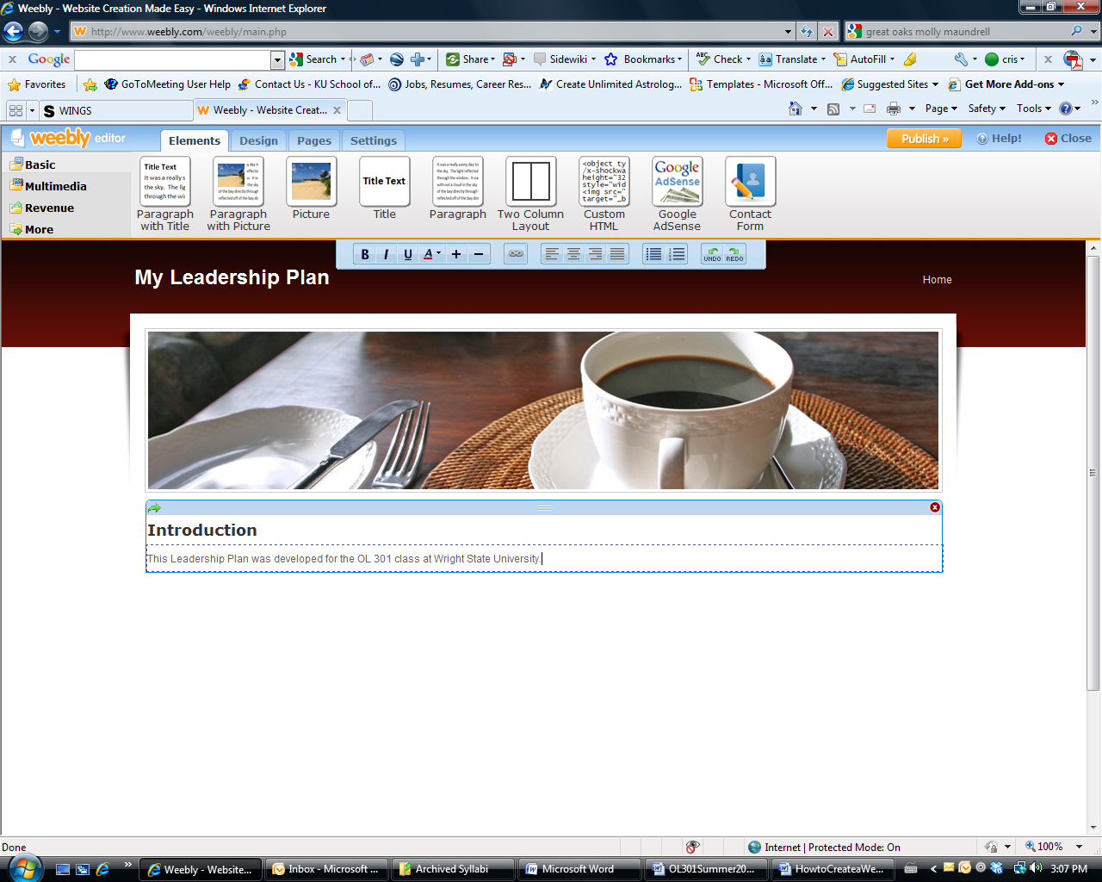

10. Add more pages by clicking on the PAGES tab

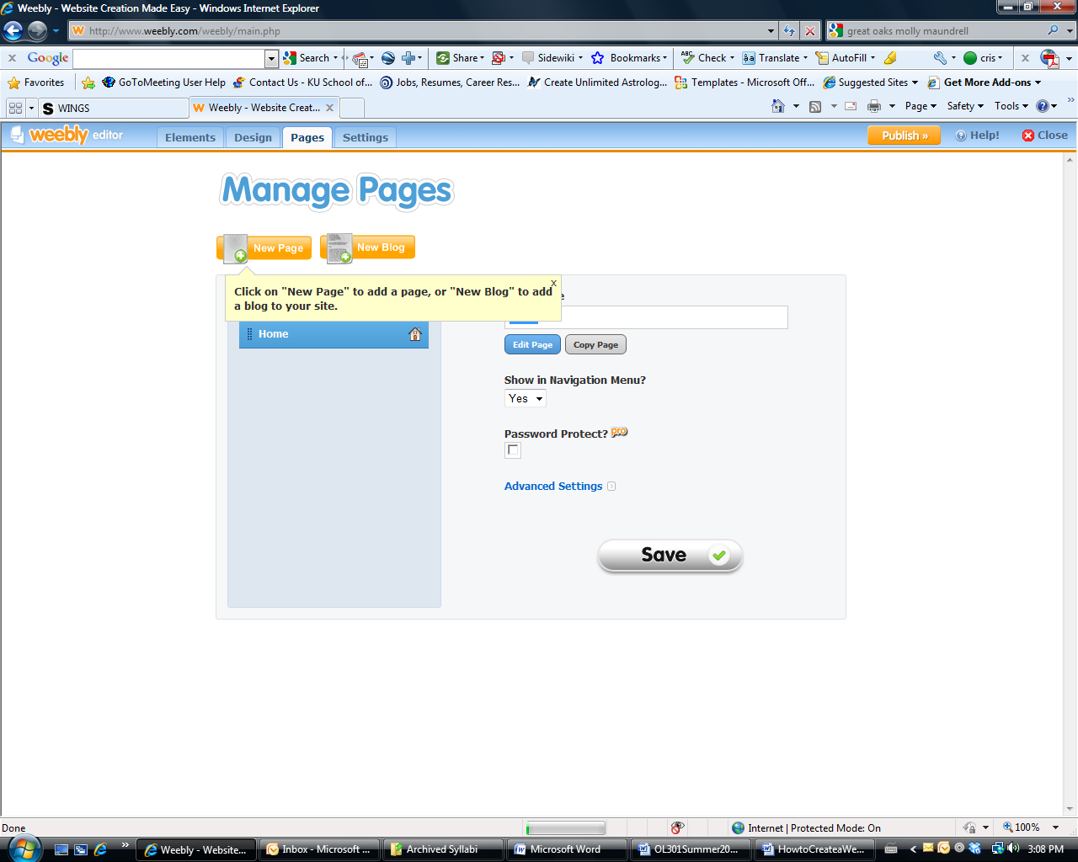

11. Click on “New Blog” to create a BLOG. Click SAVE.
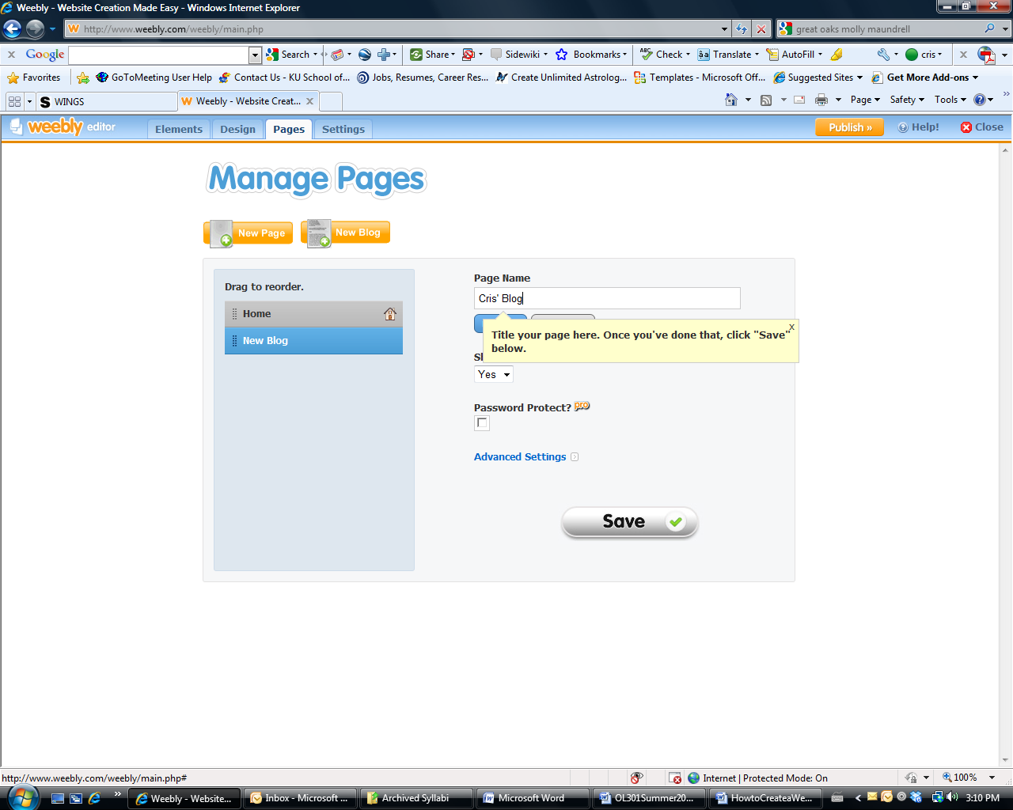

12. Congratulations, now you have a BLOG. Click on EDIT to enter your text. You may also click on “First Post”and enter a different title.
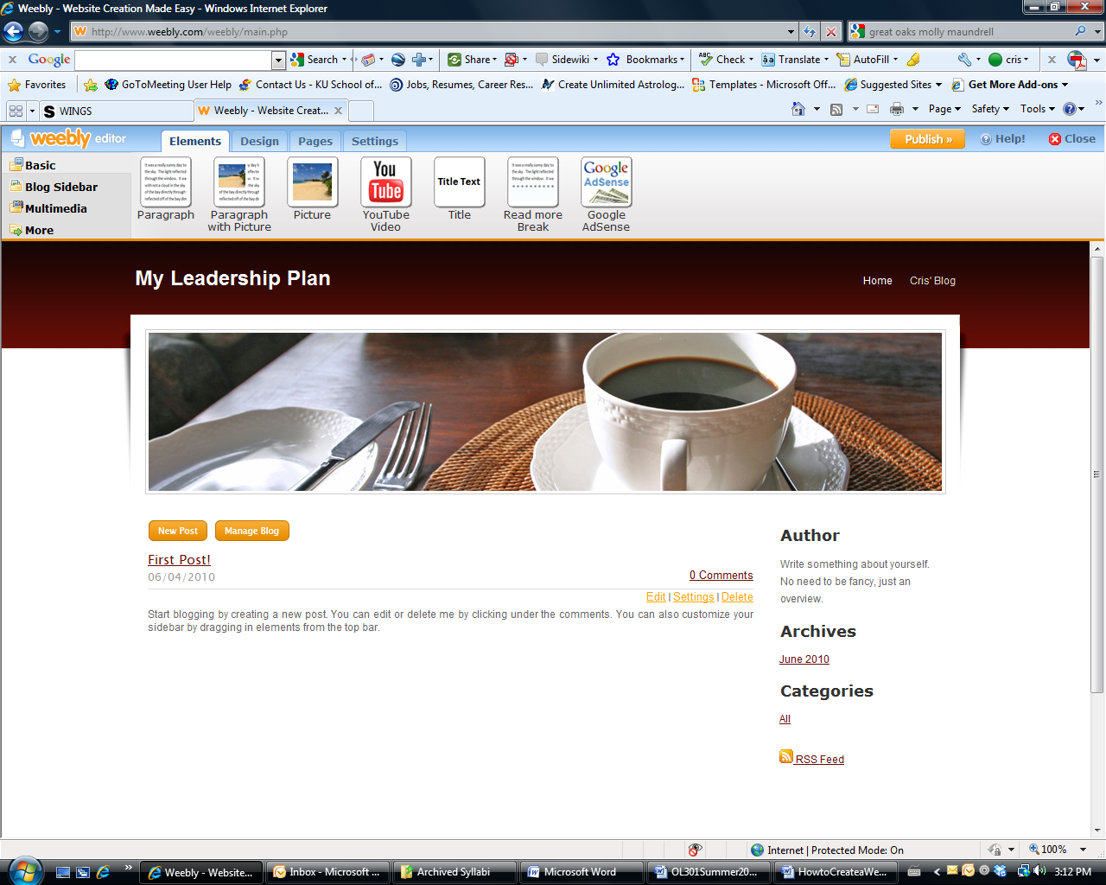

13. Here is my first post. You must click on PUBLISH to actually publish your site. Each time you enter a blog or make a change on your site, click on PUBLISH.
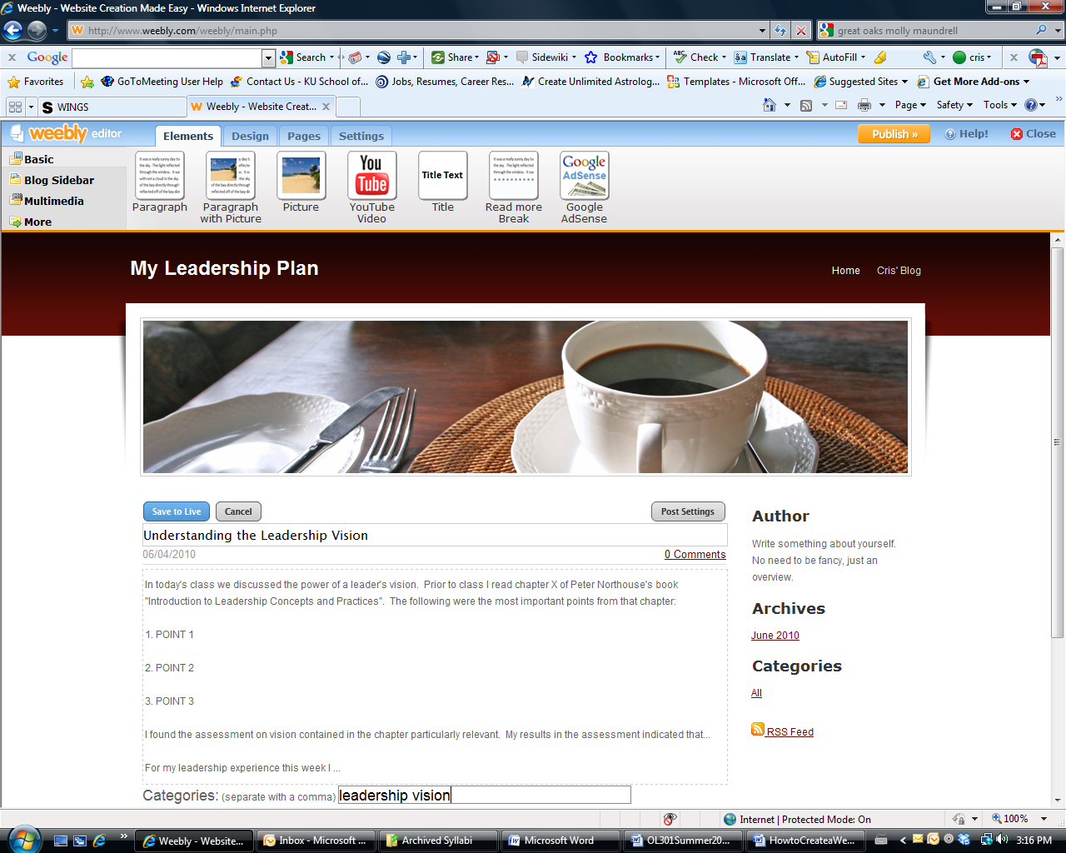
14. Great! The page is published. Click on the link to see your page.
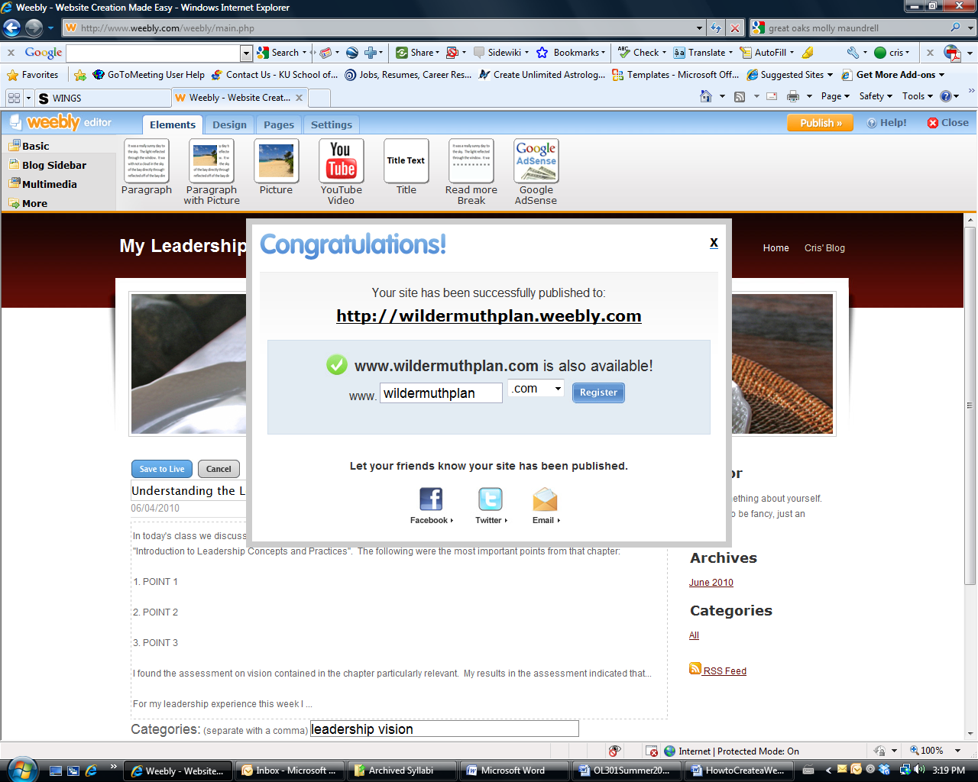
To see what I did as I was creating this tutorial for this class, go to http://wildermuthplan.weebly.com

